HOMEWORK
(Please return Homework on Thursday)

_____ Monday, March 16
Practice Spelling Words
Solve on the back or on notebook paper. (Money Word Problems)
1. Mia has 46 cents in her pocket. Lollipops cost 23 cents each. How many lollipops can Mia buy?
2. Kelly got 79 cents from her mom. Her brother took 13 cents when she wasn’t looking. Her dad gave her 21 more cents that night. How much money does Kelly have now?

3. Luke has 18 cents left over from the candy store. His friend Kim asked if she could have 10 cents for a balloon animal. Later that night Luke’s mom gave him 43 cents for doing his chores. How much money does Luke have now?

_____ Tuesday, March 17
Practice Spelling Words
Draw the minute and hour hand in the clock. Remember the minute hand is longer than the hour hand!

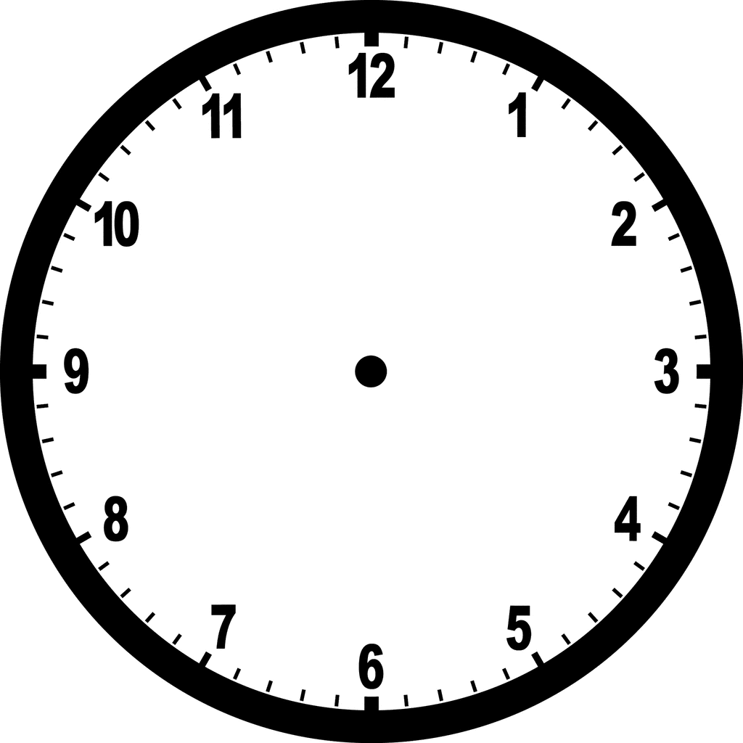
3 o’clock A quarter past 8 Midnight

Thursday, March 19
Return Homework

Friday, March 20
REMEMBER: Spelling Test! – I will test the students on last week’s spelling words and
words from previous weeks!

_____ Wednesday, March 18
Practice Spelling Words
Solve. Word Problem. (Use the back of the paper)

- Jake bought some fruit. He got 12 apples, 5 oranges,
and some bananas. He had 32 pieces of fruit
altogether. How many bananas did Jake buy?

Number sentence:
Answer Sentence:
Strategy/Picture:

