HOMEWORK
(Please return Homework on Thursday)

_____ Monday, March 2
Practice Spelling Words
Solve (Money Problems)
1. Sarah has two quarters, and three dimes. How much money does she have?

2. Lillie needs 50 cents to buy a toy from the store. She has 1 quarter, one dime, and three pennies. Does she have enough money to buy the toy?

3. Mike found 5 nickels, two dimes, and 1 penny. How much money does he have? Does he have enough to buy a 25 cent gumball?

_____ Tuesday, March 3
Practice Spelling Words
Draw the minute and hour hand in the clock. Remember the minute hand is longer than the hour hand!

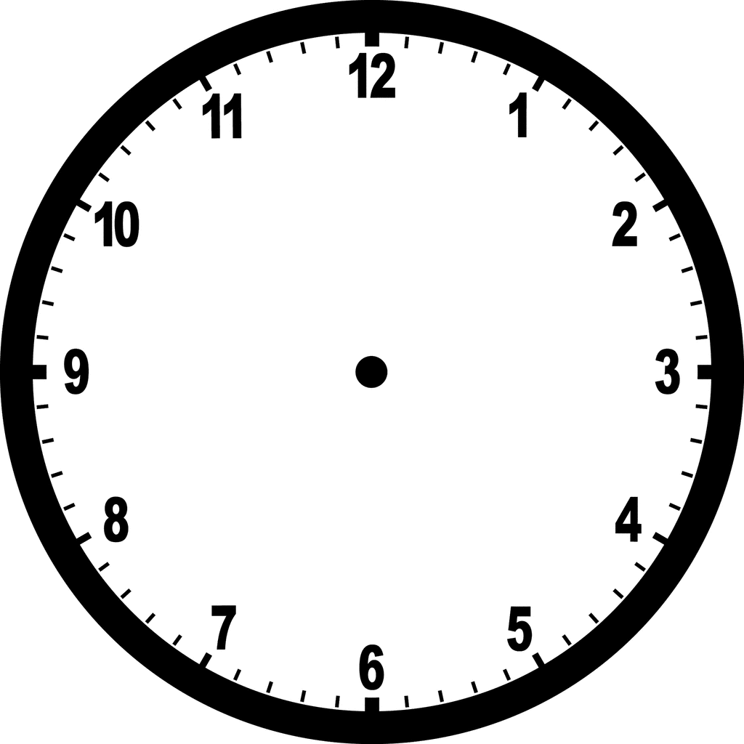
6:05 Half past 2 A quarter past 9

_____ Wednesday, March 4
Practice Spelling Words
Solve on the back or on notebook paper.
1. 19 + 75 + 21 +54 = _____
2. 39 + 80 + 27 +10 = _____
3. 14 + 52 + 76 +31 = _____
4. 10 + 12 + 45 + 32 = _____

Thursday, March 5
Return Homework

Friday, March 6
REMEMBER: Spelling Test! – I will test the students on last week’s spelling words and
words from previous weeks!

