HOMEWORK
(Please return Homework on Thursday)

_____ Monday, March 23
Practice Spelling Words
Solve on the back or on notebook paper. (Money Word Problems)
- Fio had some money in her piggy bank. She had gotten 56 cents from her brother for her birthday, 89 cents from her father for completing her chores, and she found 19 cents while cleaning her room. How much money is in her piggy bank? (Draw it out OR use coins to help solve!)

- Renata had enough money to buy two brand new notebooks. If each notebook costs the same amount and she spent 82 cents altogether, how much does each notebooks cost? (Draw it out OR use coins to help solve!)

_____ Tuesday, March 24
Practice Spelling Words
Draw the minute and hour hand in the clock. Remember the minute hand is longer than the hour hand!

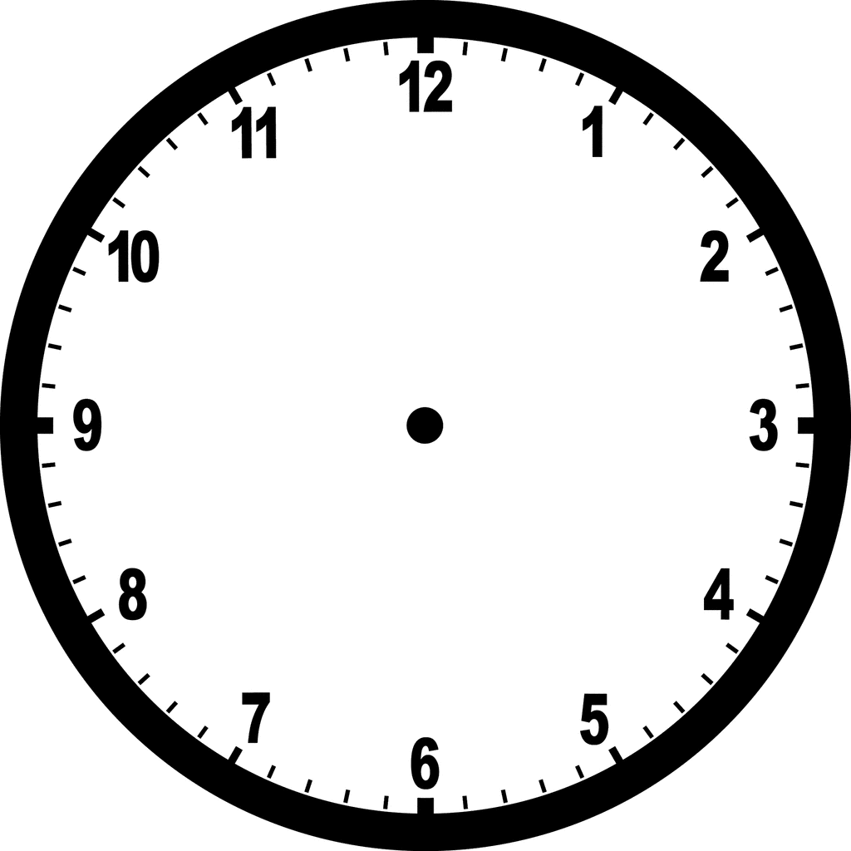
2:50 Noon 8:10
:
What does noon look like on an analog clock?

_____ Wednesday, March 25
Practice Spelling Words
Thursday, March 26
Return Homework

Friday, March 27
REMEMBER: Spelling Test! – I will test the students on last week’s spelling words and
words from previous weeks!

Solve. Word Problem. (Unknowns in all positions)

Jimmy went to the store and bought some folders
for school. He got 10 red, some yellow and 18 blue.
Altogether he bought 49 folders. How many yellow
folders did Jimmy buy?

Number sentence:
Answer Sentence:
Strategy/Picture:

