HOMEWORK
(Please return Homework on Thursday)

_____ Monday, March 9
Practice Spelling Words
Solve on the back or on notebook paper. (Money Word Problems)
1. David starts with 50 cents and spends 10 cents on marbles. How much money does David have left?
2. Gloria has 99 cents and Steve has 43 cents. How much money do they have together?
3. Andrea has 58 cents and Jeffrey 27 cents. How much more does Andrea have than Jeffrey?
_____ Tuesday, March 10
Practice Spelling Words
Draw the minute and hour hand in the clock. Remember the minute hand is longer than the hour hand!

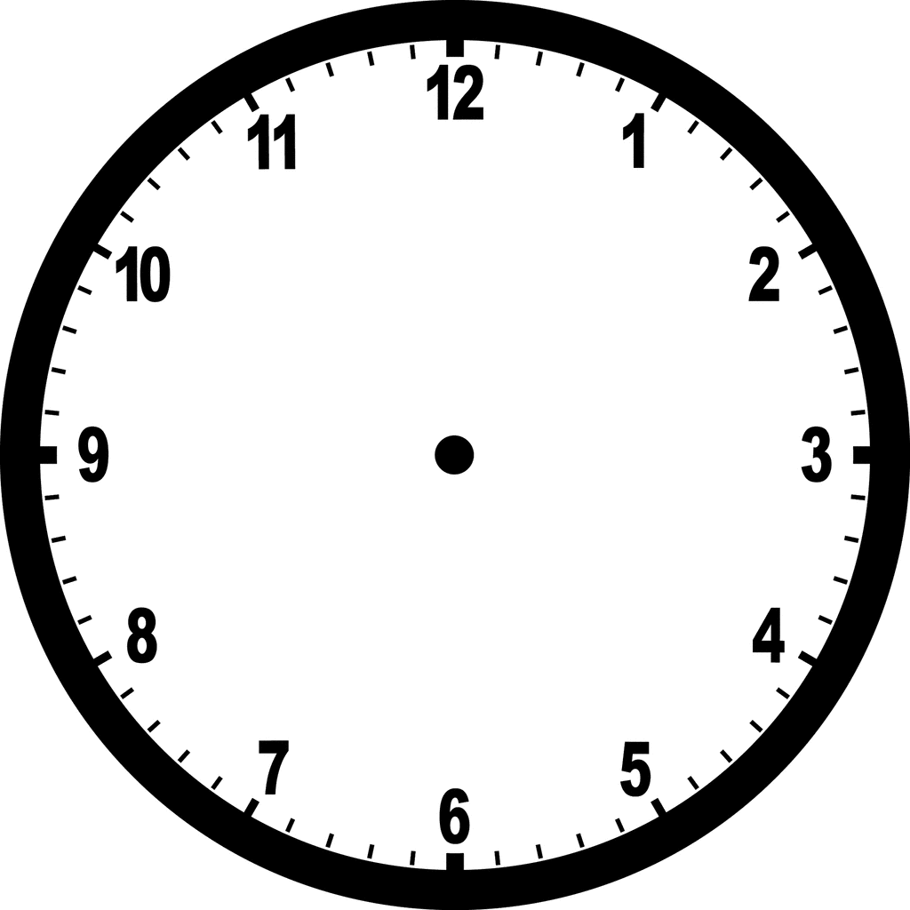
Half past 11 A quarter past 1 12:00

_____ Wednesday, March 11
Practice Spelling Words
Answer these questions by filling in the analog clock.
Thursday, March 12
Return Homework

Friday, March 13
REMEMBER: Spelling Test! – I will test the students on last week’s spelling words and
words from previous weeks!

What time do you go to bed?

What time do you wake up?

